|  |  |
| --- | --- |
| **Name:** | MANSI UNIYAL |
| **Roll Number:** | 19EE10039 |

**Experiment No. 1**

**Name of the Experiment:** Familiarization with Resistors, Capacitors and Inductors.

1. **Aim of the experiment**

* Resistors
  + Explain the function and unit of Resistors
  + Measure the value of a Resistor
  + Measure the Tolerance of a Resistor
  + Explain the types of Resistors
* Capacitors
  + Provide a definition of capacitor and name its units
  + Explain how a capacitor can be constructed to give a particular value of capacitance
  + Explain why a capacitor has maximum working voltage
  + Determine experimentally the energy stored in a capacitor
  + Identify the value and type of capacitor
  + Identify the polarity of terminals
* Inductors
  + Explain Function of Inductor
  + Explain the factors influencing inductance

1. **Tools used:**

* V-labs
* Carbon Film Resistors
* Metal Film Resistor
* Wire Wound Resistors
* Ceramic Capacitors
* Electrolytic Capacitor
* Tantalum Capacitor
* Un-polarized Capacitors- small values (up to 1uF)
* Un-polarized Capacitors — Capacitor Number Code
* Inductors

1. **Background knowledge (brief):**

* Resistors

It is a passive component. It dissipates the power into heat or light or any other form of energy. It affects the current uniformly at all times.

* + Carbon Film Resistors
    - Most general purpose, cheap resistor
    - Tolerance of Resistance value is usually +/- 5%
    - Power ratings of 1/8 W ,1/4 W and ½ W are usually used
    - Con: Tend to be electrically noisy

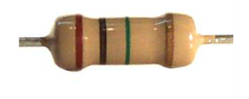

* + Metal Film Resistor
    - Used when higher tolerance is needed, ie. more value.
    - They have about +/- 0.05% tolerance

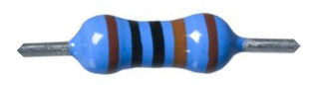

* + Wire Wound Resistors
    - A wire wound resistor is made of metal resistance wire, and because of this they can be manufactured to precise values
    - Also, high wattage resistors can be made by thick wire material
    - Wire wound resistors in a ceramic case are called as ceramic resistors
* Capacitors

Capacitor is a passive component, also known as condenser. Capacitor is generally used to store the charge. The energy is stored in “electrical field”. Capacitance is measured in Farads.

* + Classification:

|  |  |
| --- | --- |
| UN-POLARIZED | POLARIZED |
| Ceramic | Electrolytic |
| Multilayer | Tantalum |
| Polystyrene Film | Super |
| Polyester Film | They have positive and negative electrode |
| Polypropylene |  |
| Mica |  |
| They don't have positive and negative electrode |  |

* + Ceramic conductors
    - They are the most used, fixed capacitance type capacitors
    - They are usually very small (in physical dimensions and capacitance). The capacitance is usually in the range of picofarads to few micro farads (less than 10µF).
    - They are non-polarised type capacitors and hence can be used in both DC as well as AC circuits.

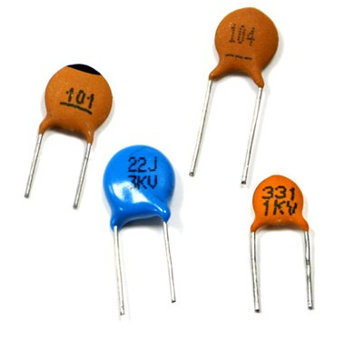

* + Electrolytic Capacitor
    - They are polarized and must be connected correct way round, at least one of their leads will be marked + or –.
    - It is very easy to find the values of electrolytic capacitors because they are clearly printed with their capacitance and voltage rating.

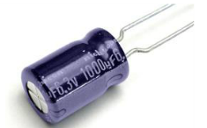

* + Tantalum Capacitor
    - Tantalum bead capacitors are polarized and have low voltage ratings like electrolytic capacitors.
    - Usually, the “+” symbol is used to show the positive component lead. Modern tantalum bead capacitors are printed with their capacitance voltage and polarity in full.
    - However older ones use a color – code systems which has two stripes (for the two digits) and a spot of color for the number of zeros to give the value in uF.

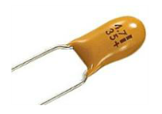

* + Un-polarized Capacitors- small values (up to 1uF)
    - The value printed but without a multiplier.
    - For example, 0.1 means 0.1 pF.
    - Sometimes the multiplier is used in place of the decimal point: For example: 4n7 means 4.7nF.

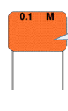

* + Un-polarized Capacitors — Capacitor Number Code
    - A number code is often used on small capacitors where printing is difficult: The 1st number is the 1st digit, the 2nd number is the 2nd digit, the 3rd number is the number of zeros to give the capacitance in pF.
    - For example: 102 means 1000pF. For example: 472J means 4700pF (J means 5% tolerance).



* Inductors

In an electronic circuit, device that controls the flow of the current is the inductor. It is a passive component that only affects the currents when they are changing in value. The energy is stored in “magnetic field”. It consists of a wire wound as a coil around a core. The core may consist of air-filled hollow tube or solid material. Its unit is Henry.

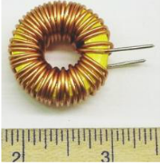

1. **Circuit (hand drawn/image)**

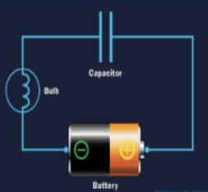

CAPACITOR CHARGING_

The plate on the capacitor that attaches to the negative terminal of the battery accepts electrons that the battery is producing. The plate on the capacitor that attaches to the positive terminal of the battery loses electrons to the battery. Once it’s charged, the capacitor has the same voltage as the battery.

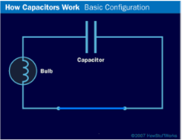

CAPACITOR DISCHARGING_

If you then remove the battery and replace it with a wire, current will flow from one plate of the capacitor to the other. The bulb will light initially and then dim as the capacitor discharges, until it is completely out.

1. **Measurement Data (Tabular form)**

* **Resistors**

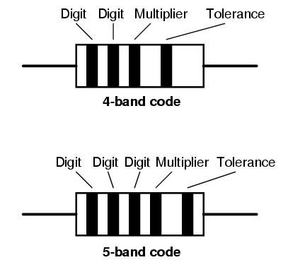

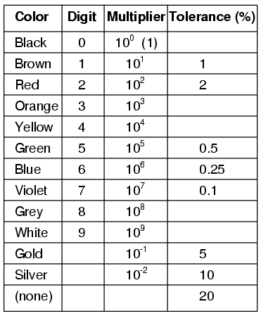

* + Resistors are colour coded as they are too small for the value to be written on them, with 4 or 5 bands of colour. Value of a Resistor is decoded from these band of colours.
  + If your resistor has four colour bands, turn the resistor so that the gold or silver band is on right hand side or the end with more bands should point left.

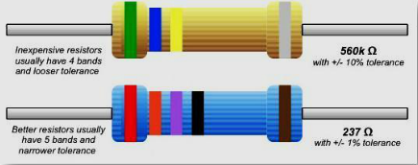

* + 4 Band Resistor
    - 1st Band 🡪 Digit
    - 2nd Band 🡪 Digit
    - 3rd Band 🡪 Multiplier
    - 4th Band 🡪 Tolerance
  + 5 Band Resistor
    - 1st Band 🡪 Digit
    - 2nd Band 🡪 Digit
    - 3rd Band 🡪 Digit
    - 4th Band 🡪 Multiplier
    - 5th Band 🡪 Tolerance
  + A 100ohm resistor with a 10 % tolerance can mean its value can be any fixed value between 90 to 110 Ohms.
* Capacitor
  + In series

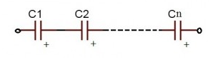

QT=Q1=Q2=−−−−−=Q

IC=I1=I2=−−−−−−=I

where,

QT 🡪 total charge,

IC 🡪 capacitive current

**1/Ceq =1/C1+1/C2**

* In parallel

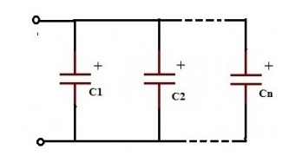

VT=V1=V2

**Ceq =C1+C2**

* Inductors
  + 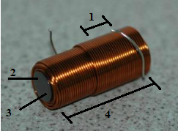The amount of inductance in Henries a coil has, is determined by the following factors –
    - No of turns of wire wound around the coil
    - Cross sectional area of the coil
    - The material type of the coil
    - The Length of the coil
  + In Series
    - 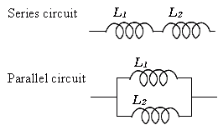IC=I1=I2

**Leq =L1+L2**

* + In Parallel
    - VT=V1=V2

**1/Leq =1/L1+1/L2**

1. **Conclusion**

* Capacitors
* Maximum Working Voltage
  + If the voltage is too high, the insulator between the plates fails to insulate and charge passes from one plate to the other. Capacitor are usually marked with the maximum working voltage to help the user avoid situation.
  + A good rule of thumb is to never place a voltage which exceeds about two thirds of this value, especially for alternating current circuits.
  + A static description would be to say Q=C×V.

Where, Q 🡪 total charge, C 🡪 measure of how big the capacitor is and V 🡪 voltage across it.

* + A dynamic description, current is the rate at which charge flows. This essentially says – the bigger the current, the faster the capacitor’s voltage changes.

|  |  |
| --- | --- |
| Capacitors | Inductors |
| Rate of change of voltage in a capacitor depends upon the current through it | Rate of change of current in an inductor depends upon the voltage applied across it. |
| Capacitive current is simply proportional to voltage | Inductive current is not simply proportional to voltage |
| The power associated with capacitive current (V times I) is not turned into heat but is stored as energy in the capacitor’s electric field. | The power associated with inductive current (V times I) is not turned into heat but is stored as energy in the inductor’s magnetic field. |

* Capacitance in series decreases and the value of equivalent capacitance increases in parallel.
* Inductors

**V= L* dl / dt**

* + L 🡪 inductance and is measured in henry.
  + Putting a voltage across an inductor causes the current to rise as a ramp

1. **Discussions**

* Capacitors

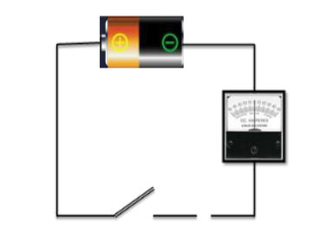

* + Consider a circuit set up like the one at the side. What will happen when the switch is closed?
    - The ammeter will show a reading of ’0’
  + Now let’s place a large metal plate at each of the connectors a few millimetres apart. What will happen when the switch is closed?
    - Flick on one side and come back to ‘0’
  + 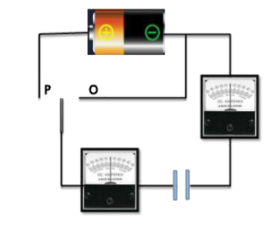Let us extend this by placing a galvanometer on both sides of the capacitor and using a two-way switch. What will happen when the switch is connected to ‘P’, For both of the Ammeters?
    - Both flicks briefly to right
  + After moving to ‘P’ now the switch is moved to ‘O’. What will happen, for both of the Ammeters?
    - Both flicks briefly to left
  + Instead of moving to ’P’ the first time, if the switch is first moved to ‘O’.
  + what will happen?
    - Both flicks briefly to left
  + The behaviour of the ammeter needles in the previous experiment suggests that a current flow firstly one way, then the other as the switch is moved from P to O. So, this suggests?
    - Equal amounts of charge flow off one plate and onto the other
  + If a battery, light bulb and a capacitor are connected – what will happen to the bulb?
    - It will glow as long as the battery is connected
* Inductor
  + If the number of turns of coil around an inductor is increased, how will the inductance change?
    - Increase
  + If the distance between the turns of coil around an inductor is increased, how will the inductance change?
    - Decrease
  + If the diameter of the coil around an inductor is increased, how will the inductance change?
    - Increase

1. **QUIZES:**

* Resistors

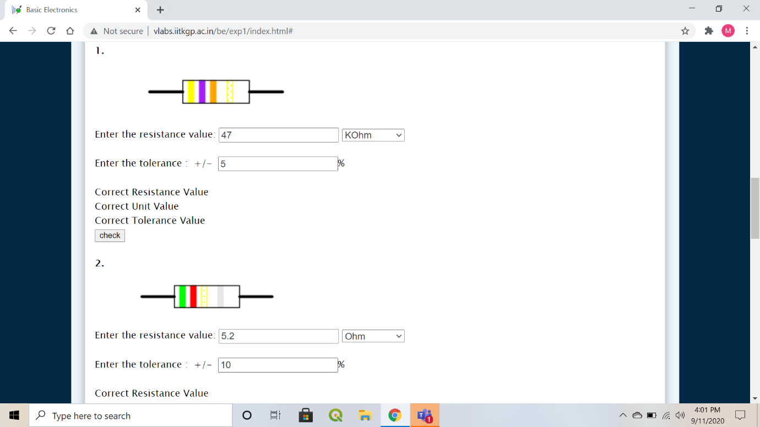

* Capacitors

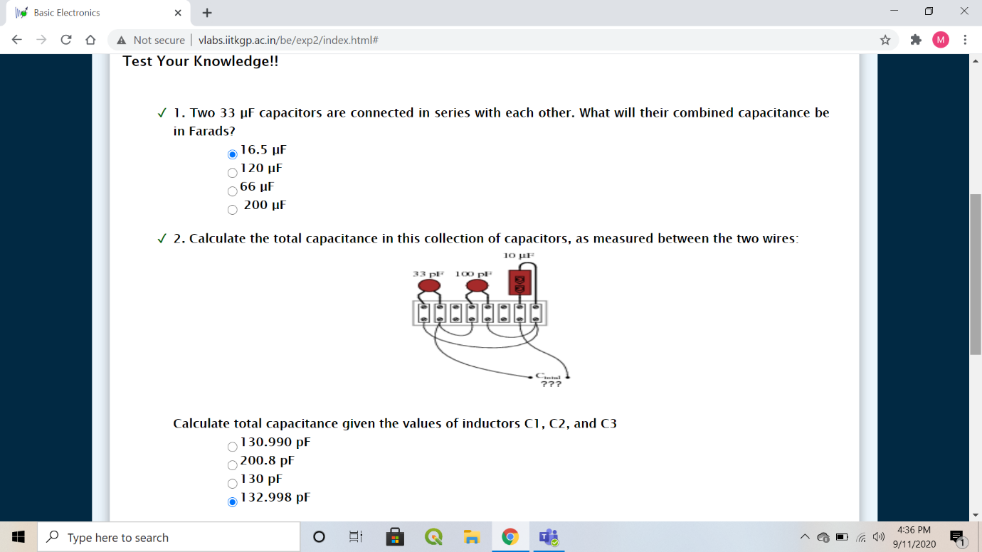

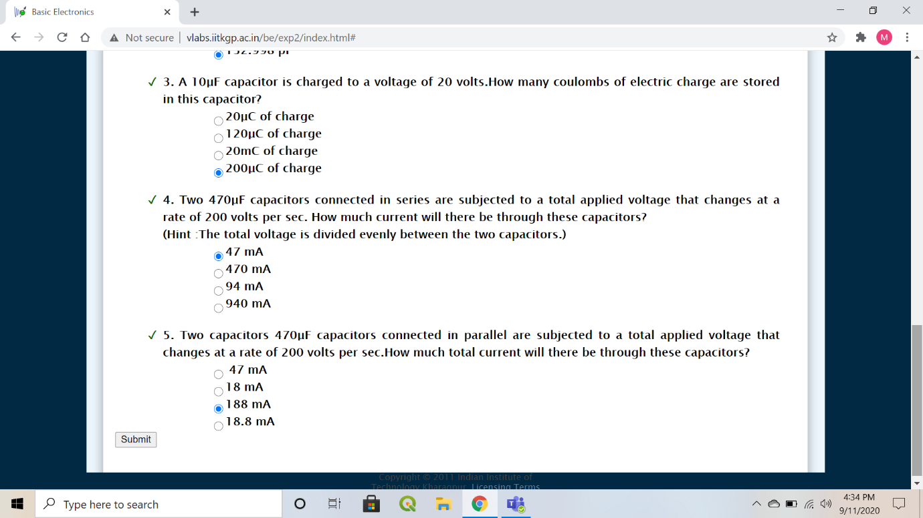

* Inductors

